**Part B Tests - Group F4**

**Initial**

Expected: Monitor window appears with all threads from all thread groups as of runtime placed in a table, displaying all relevant attributes (name, ID, state, priority, daemon status, thread group). Beneath, the operative buttons (refresh, start thread, etc).

Actual:

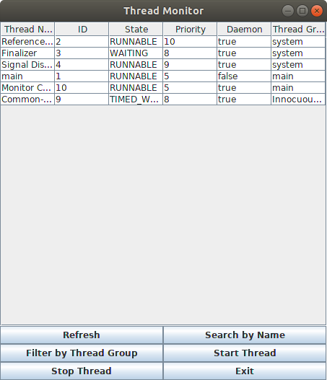

**Refresh**

Expected: Table in the Monitor is repopulated with all threads from all thread groups as of pressing the refresh button placed in a table, displaying all relevant attributes (name, ID, state, priority, daemon status, thread group).

Actual:

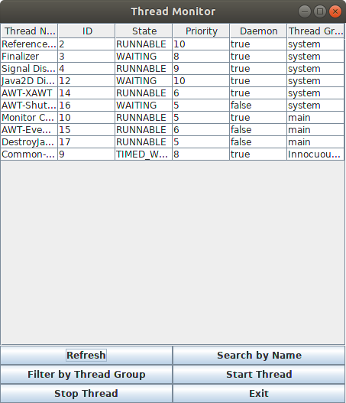

**Search By Name**

**Button Press**

Expected: Input Dialog Box appears to prompt user for input.

Actual:

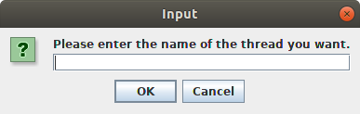

**Invalid Input (Input Not Present on Table)**

Expected: Message Dialog appears to inform user that their input is invalid.

Actual:

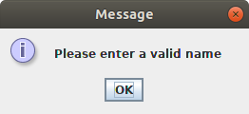

**Valid Input (Input Present on Table)**

Expected: Table is repopulated to exclusively hold the thread with name matching input.

Actual: 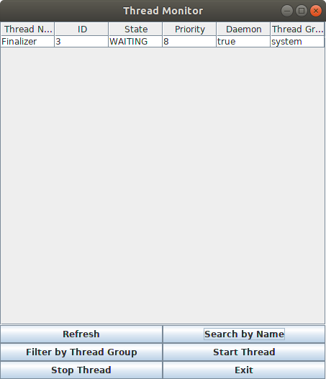

**Filter By Thread Group**

**Button Press**

Expected: Input Dialog appears prompting user for a name.

Actual:

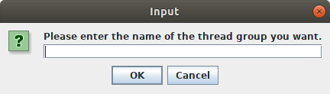

**Invalid Input (no such thread group)**

Expected: Message Dialog informing user that their input is invalid.

Actual:



**Valid Input (thread group exists)**

Expected: Table repopulates with only threads of the specified threadGroup.

Actual: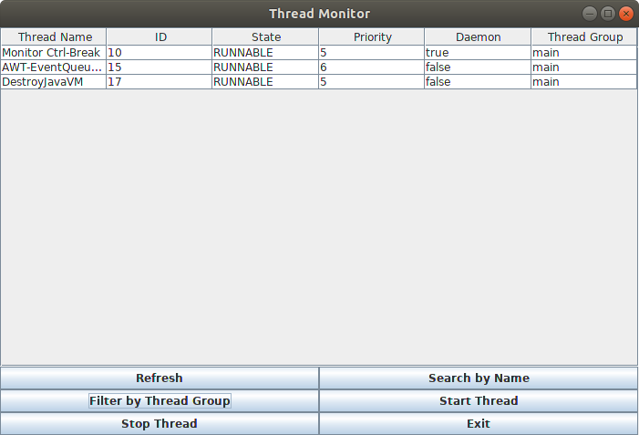

*Note: “system” thread group not considered valid input despite appearing on the table.*

**Start Thread**

**Button Press**

Expected: Input dialog appears to prompt users to name their new thread.

Actual:

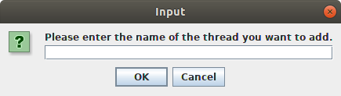

**Input**

Expected: Table adds the new thread as a new row.

Actual:

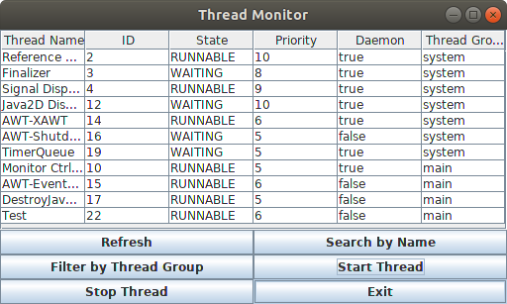

*Note: The new thread (“Test” in this case) has no function beyond looping infinitely.*

**Stop Thread**

**Button Press**

Expected: Input dialog appears to ask the user which thread they wish to terminate.

Actual:

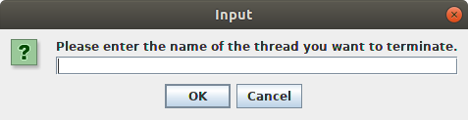

**Invalid Input (no such thread)**

Expected: Message dialog informing user that their input is not valid.

Actual:



**Valid Input (thread exists)**

Expected: Thread is terminated and table is updated to reflect this.

Actual:

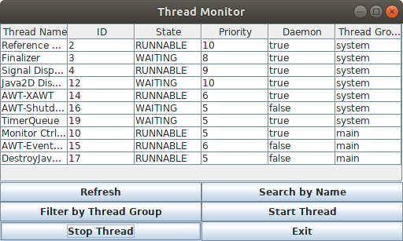

*“Test” has been deleted.*

**Exit**

**Button Press**

Expected: Window closes and application terminates.

Actual: Window closes and application terminates.

*No screenshot available (nothing to screenshot).*